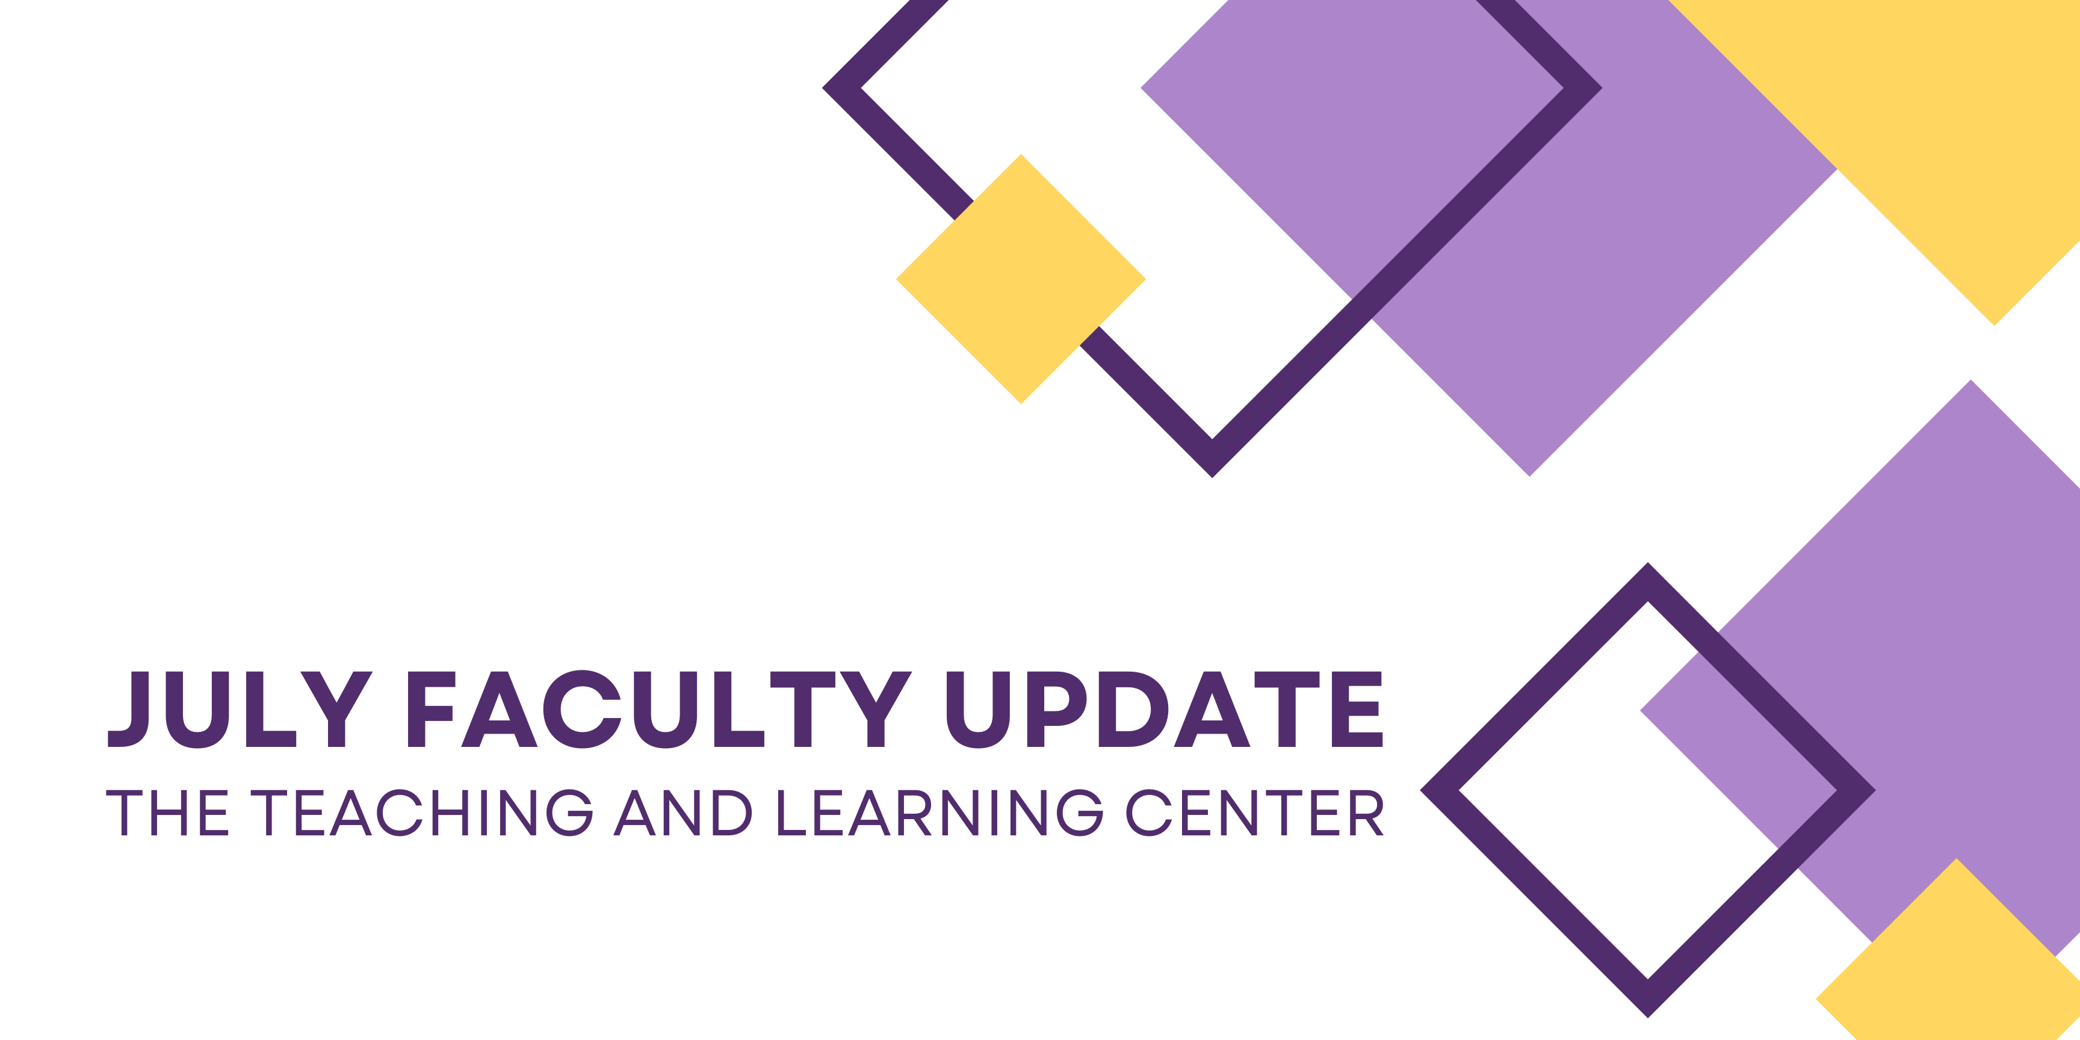

A New Name, A New Center
If you look closely at this newsletter, you will notice a new name: the Teaching and Learning Center. This is the name of a newly established center that elevates, supports, and advances teaching excellence at WCU. The TLC was formed through a merger of what was formerly the Office of Digital Learning and Innovation (ODLI), and the Teaching, Learning and Assessment Center (TLAC). Our team is working hard to get things in place to welcome you to the new center in the Fall semester. More information coming soon.

TLC Office Hours: Summer Schedule
Starting to work on your courses for next semester? Take advantage of the TLC Office Hours! Faculty can drop-in (no appointment required) to meet with one of our associate instructional designers for one-on-one support. Our designers can assist with designing courses for any modality, creating and revising learning activities and assessments, selecting and incorporating instructional technology, and adhering to accessibility standards. We look forward to seeing you during the Office Hours listed below.

Virtual Office Hours: Zoom
Monday through Thursday, 1:30pm to 2:30pm
Tuesday through Friday, 9:30am to 10:30am

NEW Online Faculty Development Program Arrives August 8
Starting on Monday, August 8, the new Online Faculty Development Program (OFD) arrives in an always available format, transitioning away from scheduled offerings. Faculty interested in completing OFD will self-enroll into the program’s D2L site using the Discover feature and start working on completing program requirements when it fits their schedule.

Faculty will now be able to access the training site to explore individual modules at their leisure or as curiosity strikes, and any work completed can be used towards certification or recertification.

To earn an initial CAPC Distance Education Certification, faculty will complete four required units, along with three more units of their choice for a total of seven units. Faculty who are pursuing CAPC Distance Education Recertification complete one required unit and three more units of their choice for a total of four units.

More details are available in the New OFD Announcement. If you have any questions about these changes, please contact the Teaching and Learning Center.

Call for Applications: Pedagogical Innovations Faculty Learning Community
The Teaching and Learning Center (TLC) and the Office of Research and Sponsored Programs (ORSP) are pleased to announce a call for applications to participate in an interdisciplinary Faculty Learning Community (FLC). Using the framework of scholarship of teaching and learning (SOTL), faculty selected to participate in the FLC will develop pedagogical strategies to promote student engagement and retention, assess the benefit of these strategies to student learning, and evaluate the impact on student engagement and retention. More details about the opportunity are available on the Call for Applications.

Applications are due by Monday, July 31, 2023.

ODLI on Air Podcast
A special surprise summer solstice episode, OLC Conference Recap arrived on June 21. If you are curious about the state of online learning broadly or how members of the TLC think about our work, check it out. Another surprise episode drops later in July. If you are a regular listener of the podcast, we already hinted at when it will arrive.
Season 3 starts on August 30.

