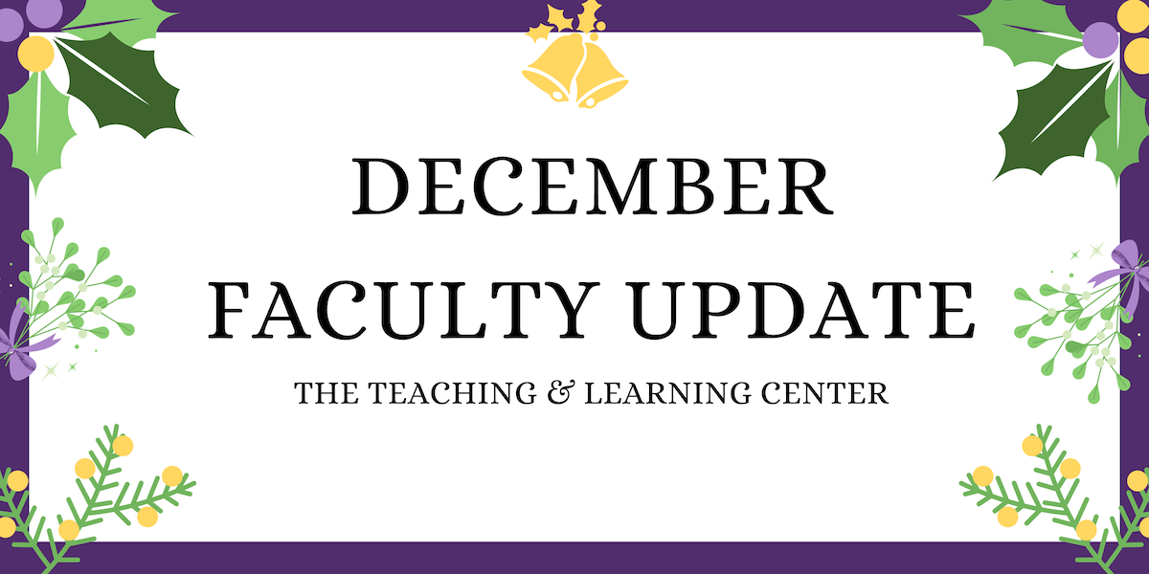

Season’s Greetings!
Happy Holidays from the Teaching and Learning Center! To celebrate together, the TLC staff have put together a playlist featuring a few favorite holiday songs from each of us. We hope that your holiday season will be joyous and restorative, and we look forward to seeing you again in the new year!

Open Initiatives

Teaching Circle: Grading Practices and Extended Reality
A teaching circle is a group of faculty who collectively explore a teaching topic of interest and work together to create a product reflecting their learning experience. The group collaboratively determines what product or products they wish to create at the start of the process.

Participants can expect to spend approximately 10 hours over the course of the semester engaged with the program.

In Spring 2024, teaching circles will be exploring the topics of Grading Practices and Extended Reality. For more information, see the full program descriptions on our website. If you're interested in participating, please complete the appropriate registration form:
- Grading Practices Circle Registration Form
- Extended Reality Circle Registration Form

Efficiency Meets Design: D2L Homepages Made Easy
We are seeking faculty willing to pilot new D2L Homepage Templates in Spring 2024. The Teaching & Learning Center (TLC) and IS&T’s EdTech and User Services team have collaborated to develop D2L course homepage templates, with the aim of providing students with a consistent learning environment and supporting faculty in the set up and design of their course sites.

Faculty participants in this pilot will be asked to:
- Adopt a D2L Homepage Template in the course(s) they specify during registration
- Participate in a pre-survey and a post-survey via Qualtrics
- Ask students in their course(s) to participate in a pre-survey and post-survey via Qualtrics

All faculty are eligible to participate. For more information, see the full program description on our website.

If you are interested in participating in this pilot, please complete the Spring 2024 Pilot Registration Form by Friday, January 12.

Upcoming Events & Workshops

Registration Open: Teaching Strides
Teaching Strides will return in Spring 2024. To better accommodate busy schedules, we are asking those interested in participating to sign up, and then we will work to find a common time for our weekly walk.

Applying the Quality Matters Rubric Training
This full day, in person workshop will renew your CAPC Distance Education Training Credential and award you the official QM APPQMR Certificate of Completion. It is facilitated by WCU instructional designers.

The training will be held on Friday, January 12 from 8:30am to 4:00pm. Participants must attend the whole day. If you'd like to attend, complete the APPQMR interest form.

Faculty Fusion: Hot Topics with the TLC
Need help transitioning out of holiday mode before the Spring semester? Looking for ways to keep Winter class momentum rolling? Register today for Faculty Fusion!
- When: January 17, 2024 from 9:00am to 1:00pm
- Where: The Foundation
- What: An in-person set of three interactive panels covering hot topics to help you prepare for the new semester.

Featured "hot" topics:
- Pedagogy of Care: Supporting Mental Health through Instructional Practices
- Using AI for Teaching
- Addressing Micro-Aggressions in the Classroom

Each session will include 30 minutes of presentation from a panel of WCU faculty experts, followed by 20 minutes of Q&A and table conversations with your peers. Coffee and lunch will be provided.

Program Updates

TLC Feedback Survey
The Teaching and Learning Center relies on your feedback to make sure our programming and resources support, celebrate, and inspire excellence and innovation in teaching! We invite you to share your thoughts and insights regarding the resources and opportunities we've provided this semester.

The TLC Feedback Survey should take about 10 – 15 minutes to complete. Responses are anonymous and will be used to improve TLC programs and services.

Online Faculty Development Program
Faculty interested in completing OFD can now self-enroll into the program’s D2L site using the Discover feature and start working when it fits their schedule. More details are available in the New OFD Announcement. If you have any questions about these changes, please contact the Teaching and Learning Center.

Stay Connected

ODLI on Air Podcast
Have you listened to our newest episodes on Generative A.I. in teaching with Dr. Famiglietti and Dr. Rademaekers?

Episodes will continue to publish over the winter break and will cover topics like the HR intern program, universal design for learning, the D2L Fusion conference, and being a Quality Matters reviewer.

The full episode catalog is available at ODLI on Air Podcast.

Connect with Us
The Teaching and Learning Center is far more than just a newsletter! Our website hosts a variety of teaching resources and our full Event Calendar. To get in touch, feel free to send us an email, or stop by our drop-in hours to speak live with one of our designers.

