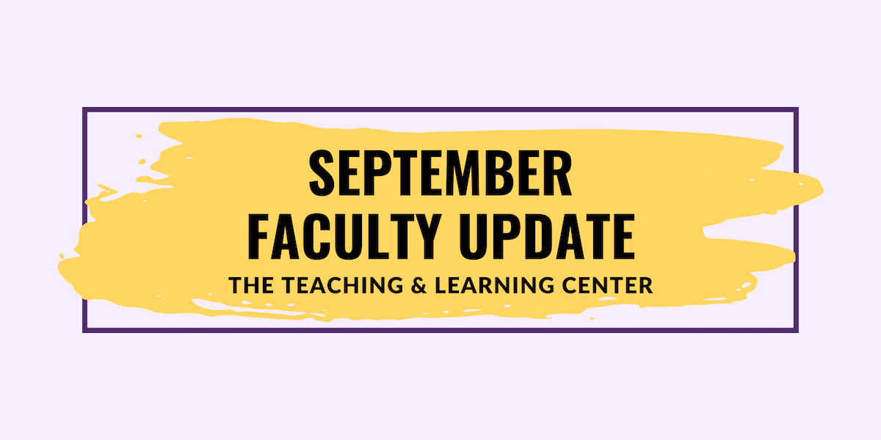

Open Calls & Initiatives

(Due Sep 16) Fall 2024 Teaching Circles
A teaching circle is a group of faculty who collectively explore a teaching topic of interest and work together to create a product reflecting their learning experience. The group collaboratively determines what product or products they wish to create at the start of the process.
This Fall semester, two teaching circles are forming: Generative Artificial Intelligence and Science of Learning. To learn more or sign up, see the full program description on our website.

(Due Sep 16) Teaching Triangles
A teaching circle is a group of faculty who collectively explore a teaching topic of interest and work together to create a product reflecting their learning experience. The group collaboratively determines what product or products they wish to create at the start of the process.
This Fall semester, two teaching circles are forming: Generative Artificial Intelligence and Science of Learning. To learn more or sign up, see the full program description on our website.

(Due Sep 20) 2024-25 Diversity & Inclusion Faculty Learning Community
We invite all faculty members who are interested in improving their inclusive teaching methods and promoting equitable learning outcomes to apply for the 2024-25 Diversity and Inclusion Faculty Learning Community (DI FLC). By participating in the FLC, you will join a multidisciplinary group of faculty members who will collaborate to explore and enhance equitable and inclusive teaching practices. Our goal is to create supportive and inclusive learning environments where all students feel a strong sense of belonging. To learn more, please visit the FLC website, or submit your application today! Questions can be directed to Dr. Kimberly E. Johnson (kjohnson4@wcupa.edu).

(Fall 2024) CELT Book Club
It’s time to register for the Committee for Excellence in Learning and Teaching’s Fall 2024 Book Club! We invite you to join CELT in reading and discussing José Antonio Bowen and C. Edward Watson’s Teaching with AI: A Practical Guide to a New Era of Human Learning (2024). To participate and receive a complimentary copy of the book, you must commit to attending two meetings throughout the semester: one in October and one in November.

After registering online, you may pick up your copy from the Teaching and Learning Center on Tuesdays or Thursdays starting on August 6. If you have any questions, please contact book club leaders Dawn Patterson (dpatterson@wcupa.edu) and Jenn Raskauskas (jraskauskas@wcupa.edu).

Upcoming Events
(Virtual: Sep 10) Proactive Accessibility: Minimizing Accommodation Requests through Inclusive Course Design
Have you noticed an increase in student requests for accommodations in your courses? You’re not alone! Join the OEA and the TLC on Tuesday, September 10 at 2:00pm for a workshop to explore effective strategies for supporting students with diverse learning needs and designing courses that minimize the need for individual student accommodations. This workshop is co-sponsored by the Faculty Ombuds Office. Register for the Proactive Accessibility workshop today!

(Virtual: Sep 11) Designing for Equity: Using UDL to Create an Equitable & Inclusive Classroom
Join the TLC staff on Zoom on Wednesday, September 11 at 2:00pm for a flexible format workshop to discuss the principles of Universal Design for Learning (UDL) to design equitable and inclusive classrooms. Our goal is to allow faculty to tailor the experience to their own knowledge, experience, and goals. Are you new to UDL? Do you want to improve your courses in one of the three UDL areas? We’ll have instructional designers on hand to work with you on what matters most to you. Register for the Designing with Equity workshop today!

(Virtual: Sep 12) Teaching Neurodiverse Learners
Join DCAP and the TLC on Thursday, September 12 at 2:00pm for a workshop exploring effective strategies for supporting neurodivergent students and managing a neurodiverse classroom. Register today!

(Virtual: Sep 18) Strategies for Facilitating Dialogue
This 90-minute workshop will offer resources and strategies for faculty and staff available through the Constructive Dialog Institute (CDI) platform, such as identifying constructive open-ended questions for challenging conversations, modeling reflective and active listening, and developing ready responses for unpredictable moments inside or outside of the classroom. Our facilitators will be Dr. Joan Woolfrey and Helen Hammerschmidt.

Register today for the virtual session on Wednesday, September 18 at 1:00pm for the in-person session on Tuesday, October 1!

(Virtual: Sep 25) Teaching in Turbulent Times
As a University that values diversity and inclusion, how can you ensure that our classrooms and other learning environments are places for civil discourse and respectful disagreement? This discussion will allow faculty and staff to explore this issue by examining case studies and proactively plan for these moments. This workshop was created by Dr. Tracey Robinson and is designed for participants to explore strategies for maintaining civil discourse and respectful disagreement in the classroom during contentious moments. Dr. Robinson will facilitate alongside Dr. Janneken Smucker.

Register today for the virtual session on Wednesday, September 25 at 1:00pm for the in-person session on Tuesday, October 8!

Program Updates

General Education Portfolio Training: Recording Available
General Education Council and the Provost’s Office sponsored two informational sessions on the General Education Portfolio this August. If you missed these opportunities to learn more about this gen ed requirement, don't worry: we recorded it! You can find the recording and slides on the TLC blog, along with more details about the General Education Portfolio requirement. Still have questions? Contact Director of ePortfolio, Janneken Smucker, at jsmucker@wcupa.edu.

Technology Roundup – Fall 2024
The Technology Roundup is a blog feature that is released each Fall and Spring semester to keep our community of educators informed on the latest available instructional technologies that are supported by the university. Check out the Fall 2024 edition!

Online Faculty Development Program
Need to earn or renew your CAPC distance education credential? Faculty can now self-enroll into the OFD program’s D2L site using the Discover feature! Start working whenever it fits your schedule.

Stay Connected

ODLI on Air Podcast
This month’s episodes include:
- Teaching Triangles Initiative with Dr. Patterson, Dr. Walz, & Dr. DiDomenico
- Motivating Students to Read using Active Learning with Dr. Julie Wiest
New episodes of 30 minutes or less release every other week during the semester, but if you need more right away, you can also check out the 45 episodes in the ODLI on Air catalog.

Are you interested in being a guest on the podcast? If so, email us at tlc@wcupa.edu.

Connect with Us
The Teaching and Learning Center is far more than just a newsletter! Our website hosts a variety of teaching resources and our full Event Calendar. To get in touch, feel free to send us an email, or stop by our drop-in hours to speak live with one of our designers.

