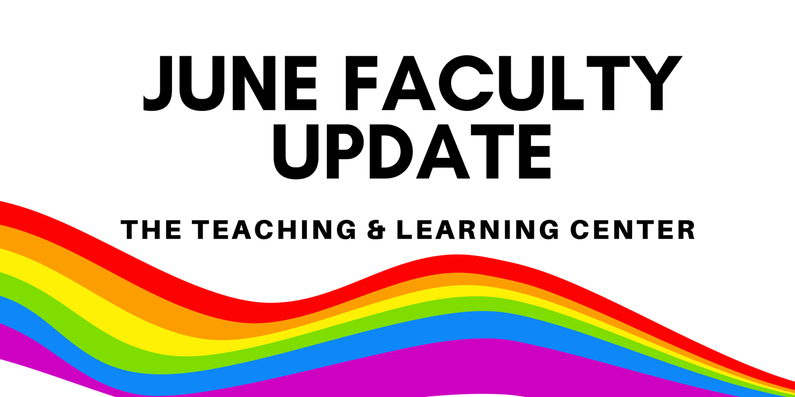

Open Calls & Initiatives

(Summer 2024) Teaching Circle: Generative AI
A teaching circle is a group of faculty who collectively explore a teaching topic of interest and work together to create a product reflecting their learning experience. The group collaboratively determines what product or products they wish to create at the start of the process.

From June 12 to July 24, a summer teaching circle will explore Generative Artificial Intelligence. To learn more or sign up, see the full program description on our website.

(Spring 2025) Program for Excellence in Teaching & Learning (PETAL)
PETAL (Program for Excellence in Teaching and Learning) invites you to participate in a semester-long experience! Join fellow educators in weekly conversations and reflections on teaching excellence. This program, sponsored by the Provost, is open to all incoming faculty and a limited number of current faculty members. Learn more about PETAL on our website. Applications are due by Thursday, August 15.

(Sep 5) PASSHE Summit: Call for Proposals
The 2024 PASSHE Summit is currently seeking proposals from faculty, staff, and students about how to cultivate and maintain environments that promote inclusive student success. The Summit will be held on October 28 & 29 in a hybrid format, with in-person sessions at Millersville University and virtual sessions on Zoom. Additional details can be found in the full Request for Proposals, and any questions can be directed to Summit co-chairs Christa Cobb (ccobb@passhe.edu), emily howe (ehowe@passhe.edu), and Carlos Wiley (carlos.wiley@millersville.edu). Proposals can be submitted online until Thursday, September 5.

(2024-25) Faculty Mentoring Committee: Call for Mentors
Are you looking for a University service opportunity? Do you want to make a significant difference in a colleague's career development? Do you want to increase your own job satisfaction? Consider becoming a mentor to your fellow faculty!
The Faculty Mentoring Committee is looking for mentors for faculty at three career stages. Tenured faculty and individuals who have participated in the adjunct faculty mentoring program for at least two semesters are invited to apply. For more information, please see the full call for mentors, or apply online.

Program Updates

New Netiquette Resource for WCU Courses
The TLC is pleased to announce the development of a new, updated Netiquette explanation! This document provides brief explanations of each concept introduced, as well as citations. We invite all faculty to provide this document as a resource in your online courses to help students understand what is expected of them when engaging in online dialogues. The updated version replaces the old Netiquette document, which will be retired on July 1: if there are any links to the old document in your courses or syllabi, be sure to update them in advance to prevent confusion.

Spring 2024 Pilot Findings and Next Steps: D2L Homepages
Thank you to everyone who participated in the Spring 2024 Pilot Program, Efficiency Meets Design: D2L Homepages Made Easy! For your convenience, we have put together this one-page report on findings from this pilot and next steps. For a more detailed look at the data, check out the full report. If you have any questions about this report, please contact the Teaching & Learning Center at tlc@wcupa.edu.

PA-ADOPT: New eTextbooks Published
The PA Alliance for Design of Open Textbooks is pleased to announce the availability of two new free and open textbooks: Intro to Journalism Handbook by Dr. Michael Downing, Professor of English at Kutztown University, and Building User Interfaces for Modern Web Applications: React Programming by Dr. Cheer Sun Yang, Professor of Computer Science at West Chester University. To learn more, check out our blog!

Online Faculty Development Program
Need to earn or renew your CAPC distance education credential? Faculty can now self-enroll into the OFD program’s D2L site using the Discover feature! Start working whenever it fits your schedule.

Stay Connected

ODLI on Air Podcast
Season 4 wrapped up last month with part 2 of our AI conversation with Eryn Travis and a discussion on open science resources with Dr. Megan Fork and student Jessica Buchser. The podcast takes a break from its regular every other week publishing schedule over the summer, making it a great time to catch up on episodes you might have missed! We'll be back with Season 5 on August 30, 2024.

Connect with Us
The Teaching and Learning Center is far more than just a newsletter! Our website hosts a variety of teaching resources and our full Event Calendar. To get in touch, feel free to send us an email, or stop by our drop-in hours to speak live with one of our designers.

