**WCU Master of Science in Applied Statistics - Non-Thesis option**

**Graduate Advising Sheet. (33-34 credits)**

Student Name: _____________________WCU ID # _________________ Semester accepted ______________

**Core Curriculum (24 credit hours) Semester Year Grade**

STA 503 (1) Introduction to R Programming ________ ____ _____

STA 505 (3) Mathematical Statistics 1 or ________ ____ _____

STA 504 (4) Mathematical Statistics w/Calculus Review ________ ____ _____

STA 506 (3) Mathematical Statistics II ________ ____ _____

STA 507 (3) Introduction to Categorical Data Analysis ________ ____ _____

STA 511 (3) Introduction to Statistical Computing

and Data Management ________ ____ _____

STA 512 (4) Principles of Experimental Analysis ________ ____ _____

STA 513 (4) Intermediate Linear Models ________ ____ _____

STA 514 (3) Modern Experimental Design ________ ____ _____

**Internship in Applied Statistics (Optional) Semester Year Grade**

STA 601 Internship ________ ____ _____

**Applied Statistics Elective (6-9 credit hours)**

**Course** **Semester Year Grade**

1. Elective __________________________________________________ ­­­­­____________ ______ _______

2 Elective __________________________________________________ ________ ____ _____

3. Elective if Internship not elected______________________ ________ ____ _____

**Choose from:** STA 531 Topics in Applied Statistics

STA 532 Survival Analysis

STA 533 Longitudinal Data Analysis

STA 534 Time Series

STA 535 Multivariate Data Analysis

STA 536 Data Mining

STA 537 Advanced Statistical Programming Using SAS

STA 538 Statistical Programming Using R

STA 539 Applied Bayesian Methods

STA 540 Statistical Consulting

STA 541 Categorical Data Analysis II

STA 542 Observational Studies

STA 543 Statistical Methods in Business and Finance

STA 544 Marketing Analytics

STA 545 Statistical Issues in Clinical Trials

STA 551 Foundations of Data Science

STA 552 Applied Statistical Machine Learning

STA 553 Data Visualization and Infographics

**WCU Master of Science in Applied Statistics - Thesis option**

**Graduate Advising Sheet. (33-34 credits)**

Student Name: ________________________ WCU ID # _________________Semester accepted _________

**Core Curriculum (24 credit hours) Semester Year Grade**

STA 503 (1) Introduction to R Programming ________ _____ ______

STA 505 (3) Mathematical Statistics 1 or ________ _____ ______

STA 504 (4) Mathematical Statistics w/Calculus Review ________ _____ ______

STA 506 (3) Mathematical Statistics II ________ _____ ______

STA 507 (3) Introduction to Categorical Data Analysis ________ _____ ______

STA 511 (3) Introduction to Statistical Computing

and Data Management ________ _____ ______

STA 512 (4) Principles of Experimental Analysis ________ _____ ______

STA 513 (4) Intermediate Linear Models ________ _____ ______

STA 514 (3) Modern Experimental Design ________ _____ ______

**Thesis in Applied Statistics Semester Year Grade**

STA 609 (3-6) Thesis I ________ _____ ______

STA 610 (3-6) Thesis II ________ _____ ______

**Internship in Applied Statistics (Optional) Semester Year Grade**

STA 601 Internship ________ _____ ______

**Applied Statistics Elective (3-6 credit hours)**

**Course** **Semester Year Grade**

1. Elective_______________________________________________________ ________ _____ ______

2. Elective if Internship not elected_______________________________ ________ _____ ______

**Choose from:**

STA 531 Topics in Applied Statistics

STA 532 Survival Analysis

STA 533 Longitudinal Data Analysis

STA 534 Time Series

STA 535 Multivariate Data Analysis

STA 536 Data Mining

STA 537 Advanced Statistical Programming Using SAS

STA 538 Statistical Programming Using R

STA 539 Applied Bayesian Methods

STA 540 Statistical Consulting

STA 541 Categorical Data Analysis II

STA 542 Observational Studies

STA 543 Statistical Methods in Business and Finance

STA 544 Marketing Analytics

STA 545 Statistical Issues in Clinical Trials

STA 551 Foundations of Data Science

STA 552 Applied Statistical Machine Learning

STA 553 Data Visualization and Infographics

The concentration in Biostatistics and Bioinformatics differs from the general Applied Statistics degrees shown above in requiring specific elective courses relevant to Biostatistics and/or Bioinformatics. These electives include: [STA 532](http://catalog.wcupa.edu/search/?P=STA%20532), [STA 533](http://catalog.wcupa.edu/search/?P=STA%20533), [STA 537](http://catalog.wcupa.edu/search/?P=STA%20537), [STA 539](http://catalog.wcupa.edu/search/?P=STA%20539), [STA 540](http://catalog.wcupa.edu/search/?P=STA%20540), [STA 541](http://catalog.wcupa.edu/search/?P=STA%20541), [STA 542](http://catalog.wcupa.edu/search/?P=STA%20542), [STA 601](http://catalog.wcupa.edu/search/?P=STA%20601), or [STA 609](http://catalog.wcupa.edu/search/?P=STA%20609). Other STA electives may be substituted with permission of the Program Director. The concentration in Business and Marketing Analytics differs from the general Applied Statistics degrees shown above in requiring specific elective courses relevant to Business and Marketing Analytics. These electives include : [STA 534](http://catalog.wcupa.edu/search/?P=STA%20534), [STA 535](http://catalog.wcupa.edu/search/?P=STA%20535), [STA 536](http://catalog.wcupa.edu/search/?P=STA%20536), [STA 537](http://catalog.wcupa.edu/search/?P=STA%20537), [STA 538](http://catalog.wcupa.edu/search/?P=STA%20538), [STA 543](http://catalog.wcupa.edu/search/?P=STA%20543), [STA 544](http://catalog.wcupa.edu/search/?P=STA%20544), [STA 601](http://catalog.wcupa.edu/search/?P=STA%20601), or [STA 609](http://catalog.wcupa.edu/search/?P=STA%20609). Other STA electives may be substituted with permission of the Program Director. The concentration in Data Science differs from the general Applied Statistics degrees shown above in requiring STA 551 as one of the elective courses. In addition, the two other electives selected by a student in the Data Science concentration must be selected from the following list: STA 534, STA 536, STA 537, STA 543, STA 544, STA 552, STA552, STA601, or STA609. Other STA electives or CSC 545 mat be substituted with permission of the Program Director. Specific advising sheets are shown below.

|  |  |
| --- | --- |
| 1 |  |

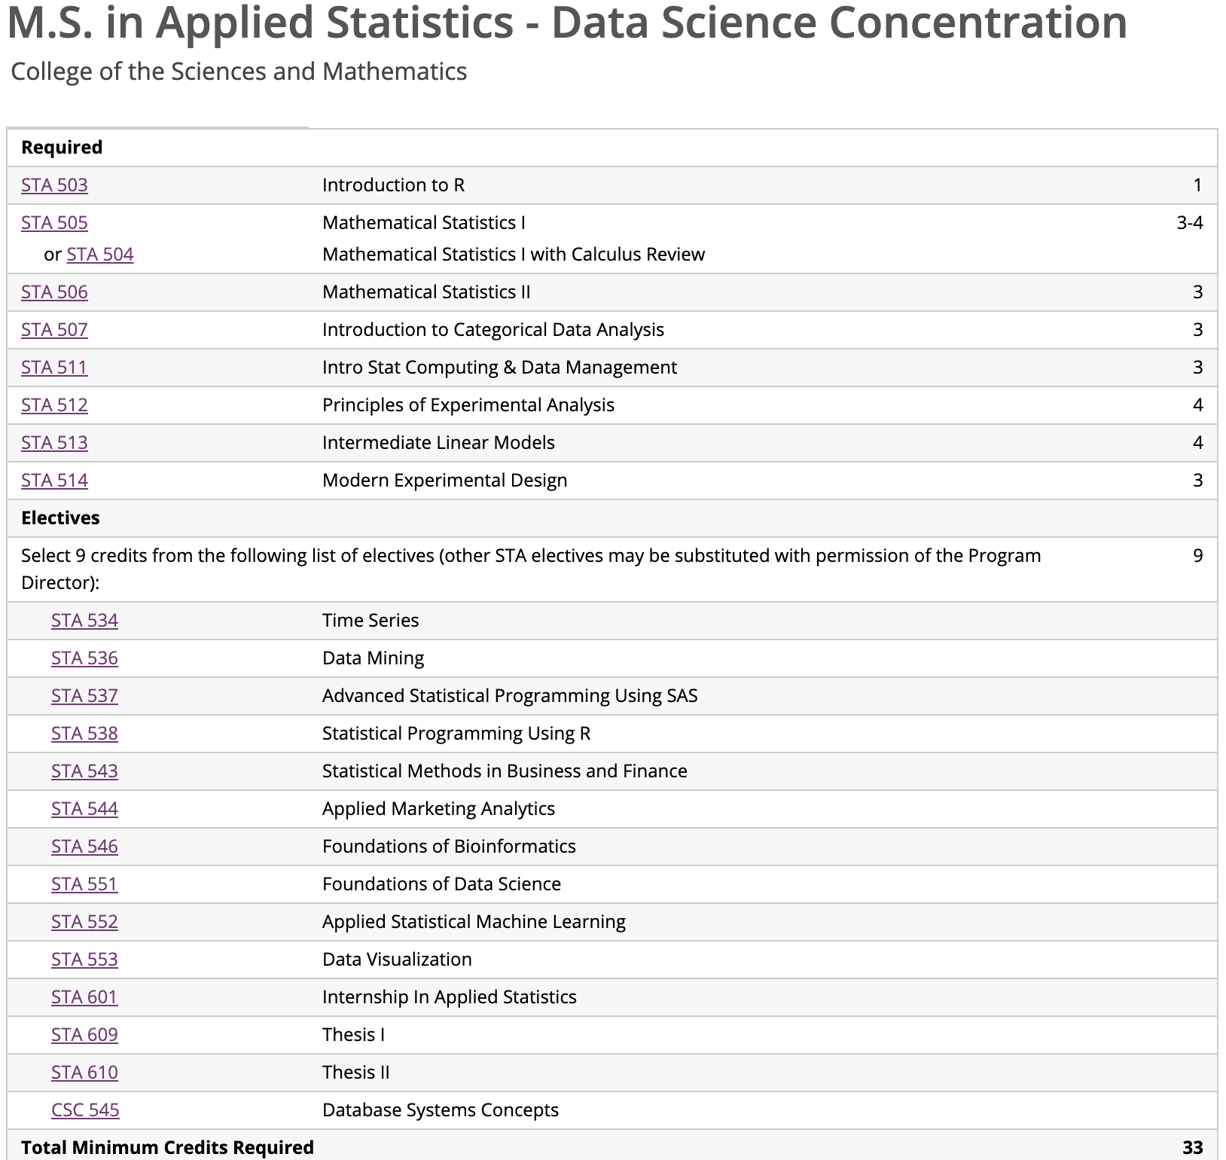

**M.S. in Applied Statistics - Biostatistics and Bioinformatics Concentration**

College of the Sciences and Mathematics

| **Code** | **Title** | **Credits** |
| --- | --- | --- |
| **Required** | |  |
| [STA 503](https://catalog.wcupa.edu/search/?P=STA%20503) | Introduction to R | 1 |
| [STA 505](https://catalog.wcupa.edu/search/?P=STA%20505) | Mathematical Statistics I | 3-4 |
| or [STA 504](https://catalog.wcupa.edu/search/?P=STA%20504) | Mathematical Statistics I with Calculus Review | |
| [STA 506](https://catalog.wcupa.edu/search/?P=STA%20506) | Mathematical Statistics II | 3 |
| [STA 507](https://catalog.wcupa.edu/search/?P=STA%20507) | Introduction to Categorical Data Analysis | 3 |
| [STA 511](https://catalog.wcupa.edu/search/?P=STA%20511) | Intro Stat Computing & Data Management | 3 |
| [STA 512](https://catalog.wcupa.edu/search/?P=STA%20512) | Principles of Experimental Analysis | 4 |
| [STA 513](https://catalog.wcupa.edu/search/?P=STA%20513) | Intermediate Linear Models | 4 |
| [STA 514](https://catalog.wcupa.edu/search/?P=STA%20514) | Modern Experimental Design | 3 |
| **Electives** | |  |
| Select 9 credits from the following list of electives (other STA electives may be substituted with permission of the Program Director): | | 9 |
| [STA 532](https://catalog.wcupa.edu/search/?P=STA%20532) | Survival Analysis |  |
| [STA 533](https://catalog.wcupa.edu/search/?P=STA%20533) | Longitudinal Data Analysis |  |
| [STA 537](https://catalog.wcupa.edu/search/?P=STA%20537) | Advanced Statistical Programming Using SAS |  |
| [STA 539](https://catalog.wcupa.edu/search/?P=STA%20539) | Applied Bayesian Methods |  |
| [STA 540](https://catalog.wcupa.edu/search/?P=STA%20540) | Statistical Consulting |  |
| [STA 541](https://catalog.wcupa.edu/search/?P=STA%20541) | Categorical Data Analysis II |  |
| [STA 542](https://catalog.wcupa.edu/search/?P=STA%20542) | Statistical Methods for Observational Studies |  |
| [STA 545](https://catalog.wcupa.edu/search/?P=STA%20545) | Statistical Design and Analysis of Clinical Trials |  |
| [STA 546](https://catalog.wcupa.edu/search/?P=STA%20546) | Foundations of Bioinformatics |  |
| [STA 601](https://catalog.wcupa.edu/search/?P=STA%20601) | Internship In Applied Statistics |  |
| [STA 609](https://catalog.wcupa.edu/search/?P=STA%20609) | Thesis I |  |
| [STA 610](https://catalog.wcupa.edu/search/?P=STA%20610) | Thesis II |  |
| **Total Minimum Credits Required** | | **33** |
| Course List | | |

|  |  |  |
| --- | --- | --- |
| **Post-Master's Certificate of Advanced Study in Applied Statistics**  Students must take four classes from the following list 1 | |  |
| [STA 531](http://catalog.wcupa.edu/search/?P=STA%20531) | Topics In Applied Statistics |  |
| [STA 532](http://catalog.wcupa.edu/search/?P=STA%20532) | Survival Analysis |  |
| [STA 533](http://catalog.wcupa.edu/search/?P=STA%20533) | Longitudinal Data Analysis |  |
| [STA 534](http://catalog.wcupa.edu/search/?P=STA%20534) | Time Series |  |
| [STA 535](http://catalog.wcupa.edu/search/?P=STA%20535) | Multivariate Data Analysis |  |
| [STA 536](http://catalog.wcupa.edu/search/?P=STA%20536) | Data Mining |  |
| [STA 537](http://catalog.wcupa.edu/search/?P=STA%20537) | Advanced Statistical Programming Using SAS |  |
| [STA 538](http://catalog.wcupa.edu/search/?P=STA%20538) | Statistical Programming Using R |  |
| [STA 539](http://catalog.wcupa.edu/search/?P=STA%20539) | Applied Bayesian Methods |  |
| [STA 540](http://catalog.wcupa.edu/search/?P=STA%20540) | Statistical Consulting |  |
| [STA 541](http://catalog.wcupa.edu/search/?P=STA%20541) | Categorical Data Analysis II |  |
| [STA 542](http://catalog.wcupa.edu/search/?P=STA%20542) | Statistical Methods for Observational Studies |  |
| [STA 543](http://catalog.wcupa.edu/search/?P=STA%20543) | Statistical Methods in Business and Finance |  |
| [STA 544](http://catalog.wcupa.edu/search/?P=STA%20544) | Applied Marketing Analytics |  |
| STA 545 Statistical Issues in Clinical Trials  STA 551 Foundations of Data Science  STA 552 Applied Statistical Machine Learning  STA 553 Data Visualization and Infographics | |  |

1 Selected courses must be different than courses already taken as part of preexisting Master's degree.  Additional courses may be selected, or exceptions made, at the discretion of the Program Director.