News Today
Issue 1
Tuesday March 25th, 2025
The Latest Social Work News
By: Nadia Libreatori
Legislative Education and Advocacy Day!
On Tuesday March 25th, 2025, some of the BSW students from West Chester University’s main campus and Philadelphia campus traveled to Harrisburg, PA to Participate in Legislative Education and Advocacy Day (LEAD) at the Pennsylvania State Capital Building.
Hundreds of students from a variety of different universities and social workers in Pennsylvania gathered at City Island early on Tuesday morning to march to the capital building. Students and social workers carried signs and yelled chants as they marched through Harrisburg advocating for two distinct house bills: HB 554 and HB 66.
WCUPA Arrives at the PA State Capitol Building
After the rally, students and social workers were greeted by the sponsoring members of NASW-PA as well as some social work supporting politicians at the steps of the Pennsylvania Capital Building. Attendees were moved by the speakers empowering speeches and were met with gratitude and appreciation for the field of social work!
Walking into the capital building, students were met with a choir singing on the steps in the foyer of the building. West Chester University students then indulged in lunch with Representative Dan Williams. Representative Willams is the state representative for the 74th legislative district serving as a democrat and a member of the PA Black Caucus. Representative Williams took time to listen to their desire for his support for HB 554 and HB 66. Representative Willams then went on to prepare the students for what our democracy may become. He urged students and social workers to “resist and protest”!
Students were then given the opportunity to meet with any representative or senator of their choosing to help advocate for their sponsorship of the bills. Many students met with the representatives of their hometown district. However, WCU students did collectively meet with Chris Pielli (Chester County State Representative) in his office to discuss their concerns and to advocate for his sponsorship of their two bills. WCU students then went on to meet with Representative Nelson to discuss the same agenda.
Last but certainly not least, collectively the WCU students in attendance were given the opportunity to meet with the Pennsylvania Speaker of the House, Joanna McClinton. Madam Speaker is the first woman to serve as the speaker of the house and her job keeps her on her toes. So, having the opportunity to meet with Joanna McClinton was an incredible honor. In this meeting WCU students were given the floor to talk about any issues they would like the Pennsylvania Congress to be aware of. Of course, HB 554 and HB 66 were mentioned but conversations around government funding and grants also circulated throughout the encounter.

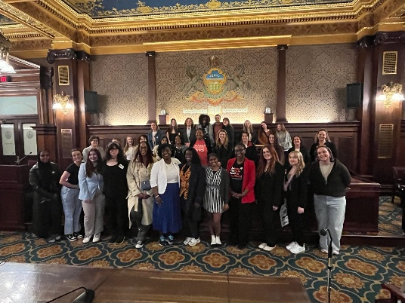

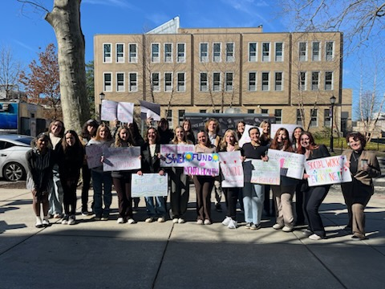

Students with their handmade rally signs

WCU students meet the PA Speaker of the House
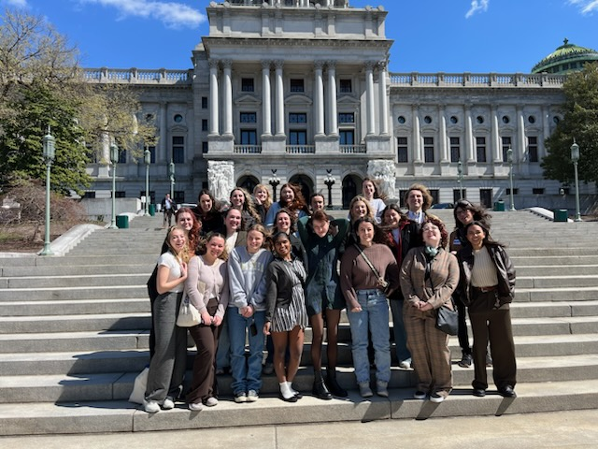
All in all, the West Chester University Social Work Department made some significant progress on uplifting the social work profession as well as the rest of the commonwealth. We are proud of our Golden Rams and we are looking forward to next year’s LEAD! Stay tuned for more information on next year’s trip to Harrisburg!
House Bill 66: The Social Worker Educational Enrollment and Training Program Act (SWEET Act), sponsored by Representative Howard, is an initiative designed to ease the financial challenges faced by Master of Social Work (MSW) students in Pennsylvania. The program provides $5,000 stipends per semester to eligible students during their internships, allowing them to focus on gaining the skills and experience necessary for licensure. This support addresses the financial burden many students face while completing unpaid or minimally compensated internships.
The SWEET Act strengthens Pennsylvania’s social services workforce by helping more MSW students complete their internships and enter the field. The increased number of licensed social workers will improve the quality and accessibility of care, particularly in underserved communities. The program also positions Pennsylvania as a leader in social work education, setting an example for other states to follow. By providing financial support for internships, the SWEET Act creates a sustainable pipeline of qualified social workers ready to meet the state’s growing social service needs (NASW-PA, 2025)
House Bill 554: HB 554 has been reintroduced by Representative Aerion Abney (D-Allegheny) to authorize Pennsylvania’s participation in the interstate Social Work Licensure Compact. It is in process of being introduced in the Senate as well by Senator Tracy Pennycuick (R-Berks/Mongomery) where it’s in the co-sponsor memo phase (no bill number yet!). If enacted, this legislation would allow social workers with an active Pennsylvania license to obtain a compact license that would enable practice in any compact state. Currently, 22 states have passed the compact legislation and it’s being proposed in an additional 18 states. Except for NY, all of the states surrounding PA have passed or are working to pass the compact.
The Social Work Licensure Compact removes barriers to practice and client care by enabling licensed social workers to work across state lines while maintaining public protection. This ensures greater access to social work services, continuity of care when clients relocate, and flexibility for social workers to meet growing demands. (NASW-PA, 2025)

What are the bills and why do they matter?

WCU students outside the PA State Capitol Building

