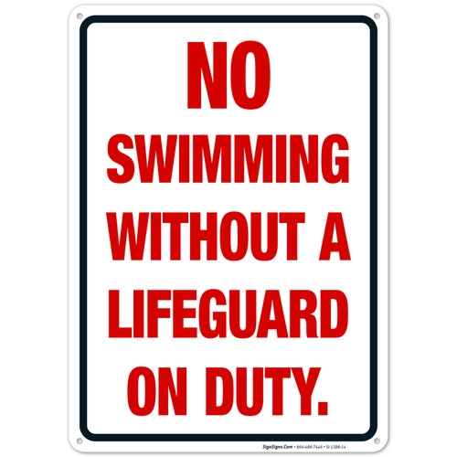

West Chester University
Fall Semester 2025

North Campus REC SWIM Schedule
NO Rec Swim on South Campus

Monday | Tuesday | Wednesday | Thursday | Friday | Saturday | Sunday
12:00 –  2:00 PM | 12:00- 2:00 PM | 12:00 –  2:00 PM | 12:00 - 1:30 PM | 12:00 – 2:00 PM | 12:00-3:00 PM | 12:00- 3:00 PM
6:30 –  9:00 PM | 6:30 –  9:00 PM | 6:30 –  9:00 PM | 6:30 –  9:00 PM | X | X | X

Present University IDs to Lifeguards for Admittance

Please rinse off before entering the pools.

First Day of REC SWIM – Monday September 8th / Last Day of REC SWIM December 7th.
Please check WCU Campus Recreational website for announcements.

Contact Pool Management (Victor Polyakov) – vpolyakov@wcupa.edu

